**Introduction to computer hardware**

Computer hardware includes the physical parts of a computer, such as the case, central processing unit (CPU), monitor, mouse, keyboard, computer data storage, graphics card, sound card, speakers,power supply unit and motherboard. By contrast, software is the set of instructions that can be stored and run by hardware.

* Motherboard

The motherboard is at the center of what makes a PC work. It houses the CPU and is a hub that all other hardware runs through. The motherboard acts as a brain; allocating power where it’s needed, communicating with and coordinating across all other components – making it one of the most important pieces of hardware in a computer.

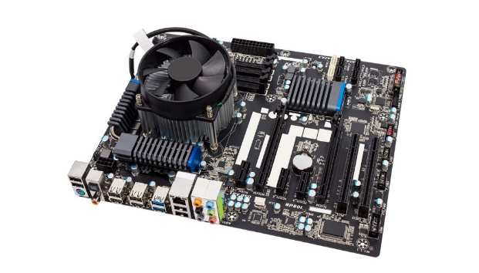

## Features of Motherboard

A motherboard comes with following features −

* Motherboard varies greatly in supporting various types of components.
* Motherboard supports a single type of CPU and few types of memories.
* Video cards, hard disks, sound cards have to be compatible with the motherboard to function properly.
* Motherboards, cases, and power supplies must be compatible to work properly together.

## Popular Manufacturers

Following are the popular manufacturers of the motherboard.

* Intel
* ASUS
* AOpen
* ABIT
* Biostar
* Gigabyte
* MSI

## Description of Motherboard

The motherboard is mounted inside the case and is securely attached via small screws through pre-drilled holes. Motherboard contains ports to connect all of the internal components. It provides a single socket for CPU, whereas for memory, normally one or more slots are available. Motherboards provide ports to attach the floppy drive, hard drive, and optical drives via ribbon cables. Motherboard carries fans and a special port designed for power supply.

There is a peripheral card slot in front of the motherboard using which video cards, sound cards, and other expansion cards can be connected to the motherboard.

On the left side, motherboards carry a number of ports to connect the monitor, printer, mouse, keyboard, speaker, and network cables. Motherboards also provide USB ports, which allow compatible devices to be connected in plug-in/plug-out fashion. For example, pen drive, digital cameras, etc.

* RAM(Random Access Memory)

 RAM, is hardware found in the memory slots of the motherboard. The role of RAM is to temporarily store on-the-fly information created by programs and to do so in a way that makes this data immediately accessible. The tasks that require random memory could be; rendering images for graphic design, edited video or photographs, multi-tasking with multiple apps open (for example, running a game on one screen and chatting via Discord on the other).

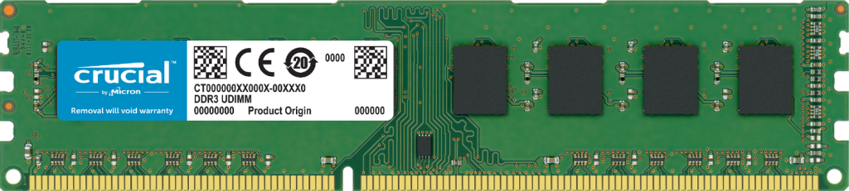

There are two main types of RAM: **Dynamic RAM (DRAM) and Static RAM (SRAM)**. DRAM (pronounced DEE-RAM), is widely used as a computer's main memory. Each DRAM memory cell is made up of a transistor and a capacitor within an integrated circuit, and a data bit is stored in the capacitor.

There are basically two kinds of internal memory: ROM and RAM.

**ROM**stands for read-only memory. It is non-volatile, which means it can retain data even without power. It is used mainly to start or boot up a computer.

Once the operating system is loaded, the computer uses **RAM**, which stands for random-access memory, which temporarily stores data while the central processing unit (CPU) is executing other tasks. With more RAM on the computer, the less the CPU has to read data from the external or secondary memory (storage device), allowing the computer to run faster. RAM is fast but it is volatile, which means it will not retain data if there is no power. It is therefore important to save data to the storage device before the system is turned off.

##### **What are the types of RAM?**

There are two main types of RAM: Dynamic RAM (DRAM) and Static RAM (SRAM).

* **DRAM**(pronounced DEE-RAM), is widely used as a computer’s main memory. Each DRAM memory cell is made up of a transistor and a capacitor within an integrated circuit, and a data bit is stored in the capacitor. Since transistors always leak a small amount, the capacitors will slowly discharge, causing information stored in it to drain; hence, DRAM has to be refreshed (given a new electronic charge) every few milliseconds to retain data.
* **SRAM**(pronounced ES-RAM) is made up of four to six transistors. It keeps data in the memory as long as power is supplied to the system unlike DRAM, which has to be refreshed periodically. As such, SRAM is faster but also more expensive, making DRAM the more prevalent memory in computer systems.

##### **What are the common types of DRAM?**

* **Synchronous DRAM (SDRAM)** “synchronizes” the memory speed with CPU clock speed so that the memory controller knows the exact clock cycle when the requested data will be ready. This allows the CPU to perform more instructions at a given time. Typical SDRAM transfers data at speeds up to 133 MHz.
* **Rambus DRAM (RDRAM)** takes its name after the company that made it, Rambus. It was popular in the early 2000s and was mainly used for video game devices and graphics cards, with transfer speeds up to 1 GHz.
* **Double Data Rate SDRAM (DDR SDRAM)**is a type of synchronous memory that nearly doubles the bandwidth of a single data rate (SDR) SDRAM running at the same clock frequency by employing a method  called "double pumping," which allows transfer of data on both the rising and falling edges of the clock signal without any increase in clock frequency.
* [**DDR1 SDRAM**](https://www.atpinc.com/products/industrial-dram-module-ddr1)has been succeeded by [**DDR2**](https://www.atpinc.com/products/industrial-dram-module-ddr2)**,**[**DDR3**](https://www.atpinc.com/products/industrial-dram-module-ddr3), and most recently, [**DDR4**](https://www.atpinc.com/products/industrial-dram-module-ddr4)SDRAM. Although operating on the same principles, the modules are not backward-compatible. Each generation delivers higher transfer rates and faster performance. The latest DDR4 modules, for example, feature fast transfer rates at 2133/2400/2666and even 3200 MT/s.

Daughterboard card

A daughterboard (or *daughter board* , *daughter card* , or *daughtercard* ) is a circuit board that plugs into and extends the circuitry of another circuit board. The other circuit board may be the computer's main board (its motherboard ) or it may be another board or card that is already in the computer, often a sound card. The term is commonly used by manufacturers of wavetable daughterboards that attach to existing sound cards.

The daughter board is a computer hardware. It is also known as the piggyback board, riser card, daughter board, daughtercard or daughter card. A daughter board is a printed circuit board which is connected to the motherboard or expansion card. As compared to the motherboard, it is smaller in size. A daughter board does not act as an expansion card. An expansion card adds extra new functions to the computer. But a daughter board that is connected to the motherboard adds or supports the main functions of the motherboard.

Daughter boards are directly connected to the motherboards. You know that expansion cards are connected to the motherboard by using the bus and other serial interfaces.  But daughter board is directly connected to the board by soldering. As an update of the motherboard or expansion card, daughter boards are released to extend the features and services of the motherboard or expansion cards.

## Functionalities of a Daughter Board

A daughter board is a circuit board that is directly connected to the motherboard or expansion card by soldering. Sometimes, people think that daughter board and expansion card are same. But this not true. They have their own functionalities. Daughter board’s functionalities are given below:

1. It is known as the piggyback board, riser card, daughtercard etcetera.
2. A daughter board is smaller than a motherboard and may have some slots like the motherboard.
3. A daughter board is a printed circuit board which is connected to the motherboard or expansion card.
4. Unlike expansion card, daughter boards are directly connected to the motherboard by soldering.
5. Daughter boards do not provide new functions to the circuit like an expansion But they extend the circuitry of the circuit in which they are plugged into.
6. Daughter boards are released by the vendors as an update of motherboard or expansion card.

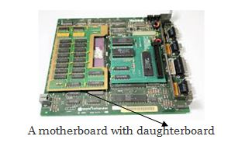

bus slot

a **bus slot** or **expansion port**, an **expansion slot** is a connection or port inside a [computer](https://www.computerhope.com/jargon/c/computer.htm) on the [motherboard](https://www.computerhope.com/jargon/m/mothboar.htm) or [riser card](https://www.computerhope.com/jargon/r/risecard.htm). It provides an installation point for a hardware expansion card to be connected. For example, if you wanted to install a new video card in the computer, you'd purchase a video expansion card and install that card into the compatible expansion slot.

Many of the below expansion card slots are obsolete.You’re most likely only going to encounter AGP, PCI, and PCI Express when working with computers today. In the picture below is an example of what expansion slots may look like on a motherboard. In this picture, there are three different types of expansion slots:**PCI Express**, **PCI**, and **AGP**.

* **PCI** – Network card, SCSI, Sound card, Video card
* **PCI Express** – Video card
* **AGP** – Video card
* **ISA** – Network card, Sound card, Video card
* **AMR** – Modem, Sound card
* **CNR** – Modem, Network card, Sound card
* **EISA** – SCSI, Network card, Video card
* **VESA** – Video card

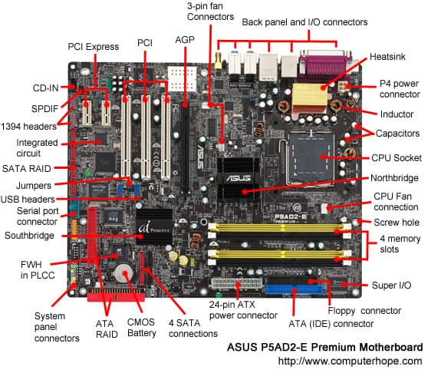

**PCI Express:**The best type of expansion slot to have in your PC is the PCI Express, also written as PCIe. Without boring you, the PCI Express type of expansion slot communicates with the motherboard, and therefore with the microprocessor, both quickly and efficiently.

**PCI:** The PCI slot is the most common form of internal expansion for a PC.

[bs_icon name=”glyphicon glyphicon-exclamation-sign”] Some PCs have a mixture of PCI and PCI Express slots. If so, go with PCI Express when you have that option.

**AGP:**This type of expansion slot was specifically designed to deal with graphics adapters. In fact, AGP stands for Accelerated Graphics Port. Older PCs may sport this expansion slot, but the best video cards use PCI Express.

**ISA:**The most ancient type of expansion slot is the ISA, which stands for (get this) Industry Standard Architecture. That’s because it never really had a name until another, better type of expansion slot came along. ISA slots hang around to be compatible with older expansion cards.

#### PCI slot

## PCI slot

#### PCI card

## PCI card

#### PCI-e slot (x16)

## PCI-e slotx16

#### PCI-e card (x16)

## PCI-e cardx16

#### AGP slot

## AGP Slot

#### AGP card

## AGP card

SMPS

A **switched-mode power supply** (**switching-mode power supply**, **switch-mode power supply**, **switched power supply**, **SMPS**, or **switcher**) is an electronic [power supply](https://en.wikipedia.org/wiki/Power_supply) that incorporates a [switching regulator](https://en.wikipedia.org/wiki/Voltage_regulator#Switching_regulators) to [convert electrical power](https://en.wikipedia.org/wiki/Electrical_power_conversion) efficiently.

Like other power supplies, an SMPS transfers power from a DC or AC source (often [mains power](https://en.wikipedia.org/wiki/Mains_electricity), see [AC adapter](https://en.wikipedia.org/wiki/AC_adapter)) to DC loads, such as a [personal computer](https://en.wikipedia.org/wiki/Personal_computer), while converting [voltage](https://en.wikipedia.org/wiki/Voltage) and [current](https://en.wikipedia.org/wiki/Electric_current) characteristics. Unlike a [linear power supply](https://en.wikipedia.org/wiki/Linear_power_supply), the pass transistor of a switching-mode supply continually switches between low-[dissipation](https://en.wikipedia.org/wiki/Dissipation), full-on and full-off states, and spends very little time in the high dissipation transitions, which minimizes wasted energy. A hypothetical ideal switched-mode power supply dissipates no power. [Voltage regulation](https://en.wikipedia.org/wiki/Voltage_regulator) is achieved by varying the ratio of on-to-off time (also known as [*duty cycles*](https://en.wikipedia.org/wiki/Duty_cycle)). In contrast, a linear power supply regulates the output voltage by continually dissipating power in the pass [transistor](https://en.wikipedia.org/wiki/Transistor). This higher power conversion efficiency is an important advantage of a switched-mode power supply.

## How does SMPS work

The SMPS device uses switching regulators that switches the load current on and off to regulate and stabilize the output voltage. The average of the voltage between the off and on produces the appropriate power for a device. Unlike the linear power supply, the pass transistor of SMPS switches between low dissipation, full-on and full-off mode, and spends very less time in the high-dissipation transitions, which minimizes wasted energy.

Switched-mode power supplies can also be substantially smaller and lighter than a linear supply because the transformer can be much smaller. This is because it operates on the switching frequency which ranges from several hundred kHz to several MHz in contrast to the 50-60Hz which is typical for the mains AC frequency. Despite the reduction in size, the power supply topology itself and the requirement for [electromagnetic interference (EMI) suppression](https://en.wikipedia.org/wiki/Electromagnetic_compatibility) in commercial designs result in a usually much greater component count and corresponding circuit complexity.

Switching regulators are used as replacements for linear regulators when higher efficiency, smaller size or lighter weight are required. They are, however, more complicated; switching currents can cause electrical noise problems if not carefully suppressed, and simple designs may have a poor [power factor](https://en.wikipedia.org/wiki/Power_factor).

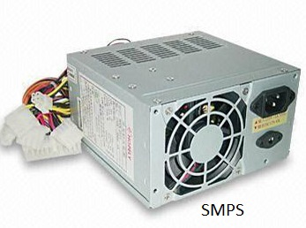

Internal storage devices

Most computers have some form of internal storage. The most common type of internal storage is the **hard disk**. At the most basic level, internal storage is needed to hold the operating system so that the computer is able to access the input and output devices. It will also be used to store the applications software that you use and more than likely, the original copies of your data files.

Internal storage allows the data and applications to be loaded very rapidly into memory, ready for use. The data can be accessed much faster than data which is stored on an external storage device. This is because internal storage devices are connected directly to the motherboard and its data bus whereas external devices are connected through a hardware interface such as USB, which means they are considerably slower to access.

Internal storage also means that if the computer is moved around, it will still retain its most commonly used data.

The main disadvantage of internal storage is that when the hard disk fails (and it will), all the data and applications may be lost.

This can be avoided to some extent by using more than one hard disk within the machine. Each hard disk has a copy of all the data, so if one fails the other can carry on. This is called a RAID array. An alternative is to use external drives for backup.

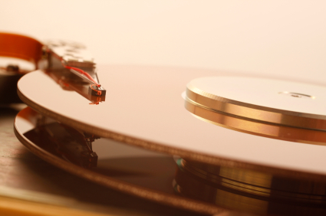

A port is a physical docking point using which an external device can be connected to the computer. It can also be programmatic docking point through which information flows from a program to the computer or over the Internet.

Interfacing ports

A port has the following characteristics −

* External devices are connected to a computer using cables and ports.
* Ports are slots on the motherboard into which a cable of external device is plugged in.
* Examples of external devices attached via ports are the mouse, keyboard, monitor, microphone, speakers, etc.

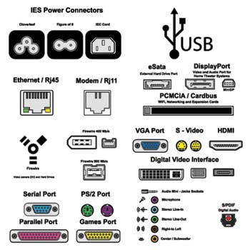

Let us now discuss a few important types of ports −

## Serial Port

* Used for external modems and older computer mouse
* Two versions: 9 pin, 25 pin model
* Data travels at 115 kilobits per second

## Parallel Port

* Used for scanners and printers
* Also called printer port
* 25 pin model
* IEEE 1284-compliant Centronics port

## PS/2 Port

* Used for old computer keyboard and mouse
* Also called mouse port
* Most of the old computers provide two PS/2 port, each for the mouse and keyboard
* IEEE 1284-compliant Centronics port

## Universal Serial Bus (or USB) Port

* It can connect all kinds of external USB devices such as external hard disk, printer, scanner, mouse, keyboard, etc.
* It was introduced in 1997.
* Most of the computers provide two USB ports as minimum.
* Data travels at 12 megabits per seconds.
* USB compliant devices can get power from a USB port.

## VGA Port

* Connects monitor to a computer's video card.
* It has 15 holes.
* Similar to the serial port connector. However, serial port connector has pins, VGA port has holes.

## Power Connector

* Three-pronged plug.
* Connects to the computer's power cable that plugs into a power bar or wall socket.

## Firewire Port

* Transfers large amount of data at very fast speed.
* Connects camcorders and video equipment to the computer.
* Data travels at 400 to 800 megabits per seconds.
* Invented by Apple.
* It has three variants: 4-Pin FireWire 400 connector, 6-Pin FireWire 400 connector, and 9-Pin FireWire 800 connector.

## Modem Port

* Connects a PC's modem to the telephone network.

## Ethernet Port

* Connects to a network and high speed Internet.
* Connects the network cable to a computer.
* This port resides on an Ethernet Card.
* Data travels at 10 megabits to 1000 megabits per seconds depending upon the network bandwidth.

## Game Port

* Connect a joystick to a PC
* Now replaced by USB

## Digital Video Interface, DVI port

* Connects Flat panel LCD monitor to the computer's high-end video graphic cards.
* Very popular among video card manufacturers.

## Sockets

* Sockets connect the microphone and speakers to the sound card of the computer.

Desktop computers

A **desktop computer** is a [personal computer](https://en.wikipedia.org/wiki/Personal_computer) designed for regular use at a single location on or near a [desk](https://en.wikipedia.org/wiki/Desk) due to its size and power requirements. The most common configuration has a [case](https://en.wikipedia.org/wiki/Computer_case) that houses the [power supply](https://en.wikipedia.org/wiki/Power_supply_unit_(computer)), [motherboard](https://en.wikipedia.org/wiki/Motherboard) (a [printed circuit board](https://en.wikipedia.org/wiki/Printed_circuit_board) with a [microprocessor](https://en.wikipedia.org/wiki/Microprocessor) as the [central processing unit](https://en.wikipedia.org/wiki/Central_processing_unit), [memory](https://en.wikipedia.org/wiki/Computer_memory), [bus](https://en.wikipedia.org/wiki/Bus_(computing)), certain [peripherals](https://en.wikipedia.org/wiki/Peripherals) and other electronic components), [disk storage](https://en.wikipedia.org/wiki/Disk_storage) (usually one or more [hard disk drives](https://en.wikipedia.org/wiki/Hard_disk_drive), [solid state drives](https://en.wikipedia.org/wiki/Solid_state_drive), [optical disc drives](https://en.wikipedia.org/wiki/Optical_disc_drive), and in early models a [floppy disk drive](https://en.wikipedia.org/wiki/Floppy_disk_drive)); a [keyboard](https://en.wikipedia.org/wiki/Computer_keyboard) and [mouse](https://en.wikipedia.org/wiki/Computer_mouse) for [input](https://en.wikipedia.org/wiki/Input_(computer_science)); and a [computer monitor](https://en.wikipedia.org/wiki/Computer_monitor), [speakers](https://en.wikipedia.org/wiki/Computer_speakers), and, often, a [printer](https://en.wikipedia.org/wiki/Printer_(computing)) for output. The case may be oriented [horizontally or vertically](https://en.wikipedia.org/wiki/Horizontal_and_vertical) and placed either underneath, beside, or on top of a desk.

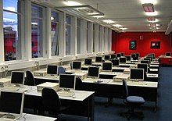

Server class computers

In [computing](https://en.wikipedia.org/wiki/Computing), a **server** is a piece of [computer](https://en.wikipedia.org/wiki/Computer) hardware or software ([computer program](https://en.wikipedia.org/wiki/Computer_program)) that provides functionality for other programs or devices, called "[clients](https://en.wikipedia.org/wiki/Client_(computing))". This [architecture](https://en.wikipedia.org/wiki/Systems_architecture) is called the [client–server model](https://en.wikipedia.org/wiki/Client%E2%80%93server_model). Servers can provide various functionalities, often called "services", such as sharing data or [resources](https://en.wikipedia.org/wiki/System_resource) among multiple clients, or performing [computation](https://en.wikipedia.org/wiki/Computation) for a client. A single server can serve multiple clients, and a single client can use multiple servers. A client process may run on the same device or may connect over a network to a server on a different device.[[1]](https://en.wikipedia.org/wiki/Server_(computing)#cite_note-1) Typical servers are [database servers](https://en.wikipedia.org/wiki/Database_server), [file servers](https://en.wikipedia.org/wiki/File_server), [mail servers](https://en.wikipedia.org/wiki/Mail_server), [print servers](https://en.wikipedia.org/wiki/Print_server), [web servers](https://en.wikipedia.org/wiki/Web_server), [game servers](https://en.wikipedia.org/wiki/Game_server), and [application servers](https://en.wikipedia.org/wiki/Application_server).[[2]](https://en.wikipedia.org/wiki/Server_(computing)#cite_note-2)

Client–server systems are usually most frequently implemented by (and often identified with) the [request–response](https://en.wikipedia.org/wiki/Request%E2%80%93response) model: a client sends a request to the server, which performs some action and sends a response back to the client, typically with a result or acknowledgment. Designating a computer as "server-class hardware" implies that it is specialized for running servers on it. This often implies that it is more powerful and reliable than standard [personal computers](https://en.wikipedia.org/wiki/Personal_computer), but alternatively, large [computing clusters](https://en.wikipedia.org/wiki/Computing_cluster) may be composed of many relatively simple, replaceable server components.

Installation of common os and server use

* **Determining Which Operating System to Install**
* **Decide whether to purchase or download.** Windows licenses need to be purchased. Each license comes with a key good for one installation. Most Linux distributions are free to download and install as much as you'd like, though
* **Research your software compatibility.** Make sure that the operating system you want to install supports the programs that you want to use. If you use Microsoft Office for work, you won't be able to install it on a Linux machine. There are substitute programs available, but the functionality may be limited.
* **Obtain your new operating system.** If you've purchased a copy of Windows from a store, you should have received an installation disc along with your product code. If you don't have the disc but have a valid code, you can download a copy of the disc online. If you are installing Linux, you can download an ISO of the distribution from the developer's website.
* An ISO file is a disc image that needs to be [burned to a disc](https://www.wikihow.com/Burn-ISO-Files-to-DVD) or copied to a [bootable USB drive](https://www.wikihow.com/Make-a-USB-Bootable)
* **Backup your data.** When you are installing a new operating system, you are most likely going to be wiping the hard drive in the process. This means that you will lose all of your files on the computer unless you back them up. Always make sure that any important files are copied to a backup location before starting the installation process. Use an external hard drive or burn the data to DVDs.
* If you are installing the operating system alongside your existing one, you most likely will not have to delete any data. It is still wise to backup important files just in case.
* You cannot backup programs; they will need to be reinstalled once you have finished installing your new operating system
* **Enter your product key.** If you are installing Windows 8, you will need to enter your product key before you can begin the installation. Older Windows versions will ask for the product key after installation is complete. Linux users will not need a product key unless it is a purchased version such as Red Hat.
* **Choose your installation type.** Windows will give you the option of Upgrading or performing a Custom installation. Even if you are upgrading an older version of Windows, it is highly recommended that you choose Custom and start from scratch. This will minimize problems that may arise later from combining old settings and new ones.
* If you are installing Linux, you will be given the option to install alongside your existing operating system (Windows), or to erase the disk and install Linux by itself. Choose the option that best meets your needs. If you choose to install alongside Windows, you will be given the option to choose how much hard disk space you want to designate for Linux.